*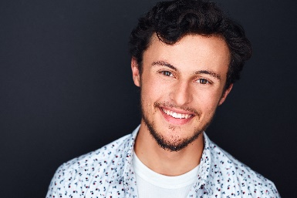Zachary Speigel*

zachspei11@gmail.com

|  |  |  |  |  |
| --- | --- | --- | --- | --- |
| Height: 5’7 | Weight: 135 | Hair: Brown | Eyes: Hazel | Voice: B3-A5-F#6 (Tenor) |

***THEATRE***

REGIONAL

*Beauty and the Beast* Lumiere Prescott Park Arts Festival David Kaye

*A Christmas Carol (National Tour)* Nephew Fred PerSeverance Productions Scott Severance

*The Wedding Singer* Ensemble Seacoast Repertory Theatre Alyssa Dumas

*Seussical* Wickersham/ Prescott Park Arts Festival David Kaye

Cat U/S (perf.)

*Theophilus North* Man #1 Square Peg Productions Matt McGonagle

*Children of Eden* Abel/Ham Derryfield Repertory Theatre Chris Kiley

*Clybourne Park* Kenneth Threshold Stage Company Charlene Kennedy

*25th Annual…Spelling Bee* Chip Tolentino Derryfield Repertory Theatre Chris Kiley

EDUCATIONAL

*If/Then \**  Lucas University of New Hampshire Deborah Kinghorn

*Mr. Burns: A Post-Electric Play* Matt University of New Hampshire David Kaye

*Pericles* Simonides University of New Hampshire Deborah Kinghorn

*The Imaginary Invalid* Argan University of New Hampshire David Kaye

*Bloody Bloody Andrew Jackson* John C. Calhoun University of New Hampshire David Kaye  
*Oedipus at Colonus* Polyneices University of New Hampshire CJ Lewis

*Big Fish* Amos Calloway University of New Hampshire Raina Ames

*The Crucible* Thomas Putnam University of New Hampshire David Richman

*\* KCACTF Irene Ryan Semi-Finalist*

***FILM***

*A Passage of Time (feature)* Mike Bill Humphreys StageWright Films

*Gone Home (feature)* Jack Nally Brandon Rose Creative Mindset Films

*Neighborhood Watch* Todd Jack Revkin Boston University

*Goodbye Kiss* Mike Arantxa Duran Emerson College

***TRAINING***

*UNH B.A. – Acting/Directing*  *Audition Workshop with Robert Westenberg*

Voice: Rachel Samet *Linklater Masterclass with Paul Ricciardi*

Melissa Manseau *Meisner Masterclass with Gary Kingston*

Dance: Mary Beth Marino *Devised Theater Workshop – KCACTF 2019*

Acting: Deborah Kinghorn

David Kaye

***SPECIAL SKILLS***

Improv, Dialects (American Southern [rhotic/non-rhotic], English [R.P./Cockney], Brooklyn), Driver’s License, Diabolo, Beatboxing, Basketball, Guitar, Piano, Basic Spanish, Whistling, Skateboarding [mediocre Ollie, even worse Kickflip.]